- Financial markets responded positively this week to reports that the US and Iran reached an agreement to extend their ceasefire. Crude oil prices fell, leading to a repricing of UK interest rate expectations.
- In a speech this week, Bank of England Governor Andrew Bailey signalled that he remains in no hurry to tighten policy. Over the next few months, we expect markets to shift further in the direction of pricing fewer interest rate hikes this year. But lingering political uncertainty and the potential for some fiscal loosening suggest rising risk premia is likely to keep longer-dated interest rates elevated.
In what has been a relatively quiet week with no major UK economic data releases of note, attention has been focused on geopolitical developments in the Middle East. The US and Iran have reportedly agreed to a tentative 60-day extension of the ceasefire, which is now awaiting US President Donald Trump’s approval.
The news has offered investors some relief after mounting fears that recent skirmishes could have led to a re-escalation. Brent crude oil prices fell to $91 per barrel, having opened the week at $101. But the key question is whether the Strait of Hormuz will reopen soon or if the extended ceasefire will only lead to another stalemate.
In response to lower oil prices, interest rate expectations have fallen across the world. But given UK interest rate expectations have been more sensitive than other markets to swings in the oil price since the Middle East conflict began, the repricing in UK rates has been larger (Chart 1). Indeed, at market close on Thursday, the two-year swap rate was 11bps lower than at the start of the week, the largest drop among G7 economies.
Chart 1: UK interest expectations have been particularly sensitive to swings in oil futures prices
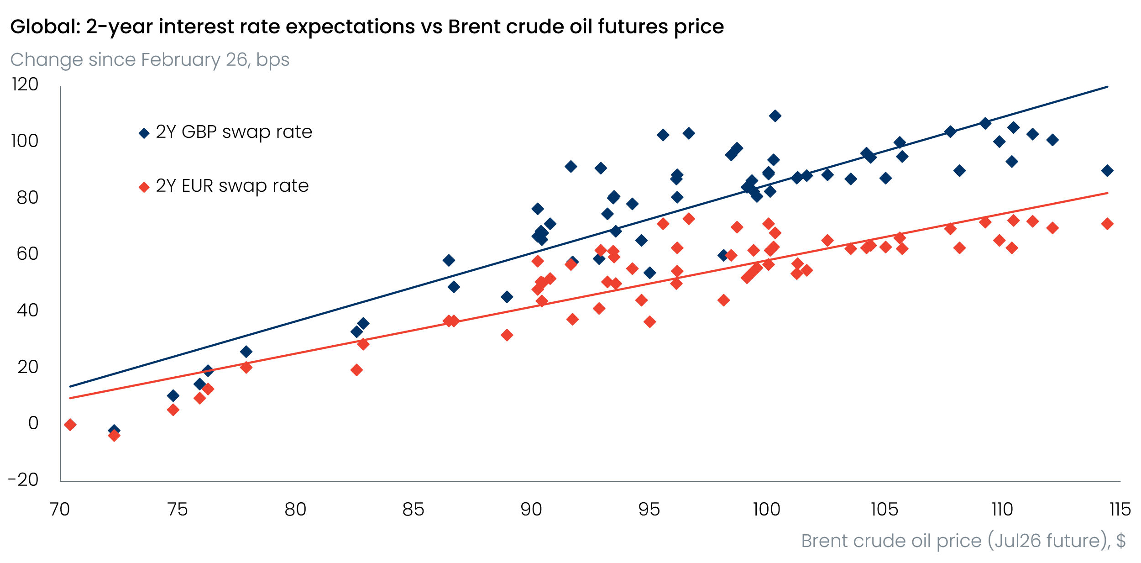
Sources: Oxford Economics, Haver Analytics

In a speech at the 2026 Reykjavik Economic Conference this morning, Bank of England Governor Andrew Bailey laid out his perspective on the judgement calls facing the Monetary Policy Committee. Bailey appeared to be in no hurry to tighten policy, highlighting that the combination of soft activity and uncertainty around the scale and duration of the energy shock means “tolerating temporarily above target inflation to provide some support for the real economy is an appropriate approach” to tackle the trade-offs posed by the latest energy shock.
Bailey has been a good bellwether for sentiments shared by the majority of MPC members in recent years. So we remain confident that Bank Rate will remain at 3.75% at the MPC’s next meeting on June 18.
Falling on the same day as the MPC’s June decision announcement, the Makerfield by-election is also likely to be a key event for the outlook. Following the Labour Party’s poor local election results earlier this month, it looks increasingly likely that Kier Starmer will be forced to stand down as Labour leader and Prime Minister. The Party appears keen to wait for Andy Burnham to stand in a by-election in Makerfield, so that if successful, he would be eligible to participate in a leadership contest.
New polling by Survation suggests Burnham only narrowly leads Reform UK candidate Robert Kenyon in what is shaping up to be a tight race (Chart 2), albeit betting markets suggest Burnham is the clear frontrunner. But even if Burnham’s bid to become a Member of Parliament again proves successful, the formal process for challenging Starmer will likely take several months to conclude, resulting in a lingering risk premium on UK government bonds.
Chart 2: The latest polling suggests Andy Burnham holds a slim lead ahead of the Makerfield by-election
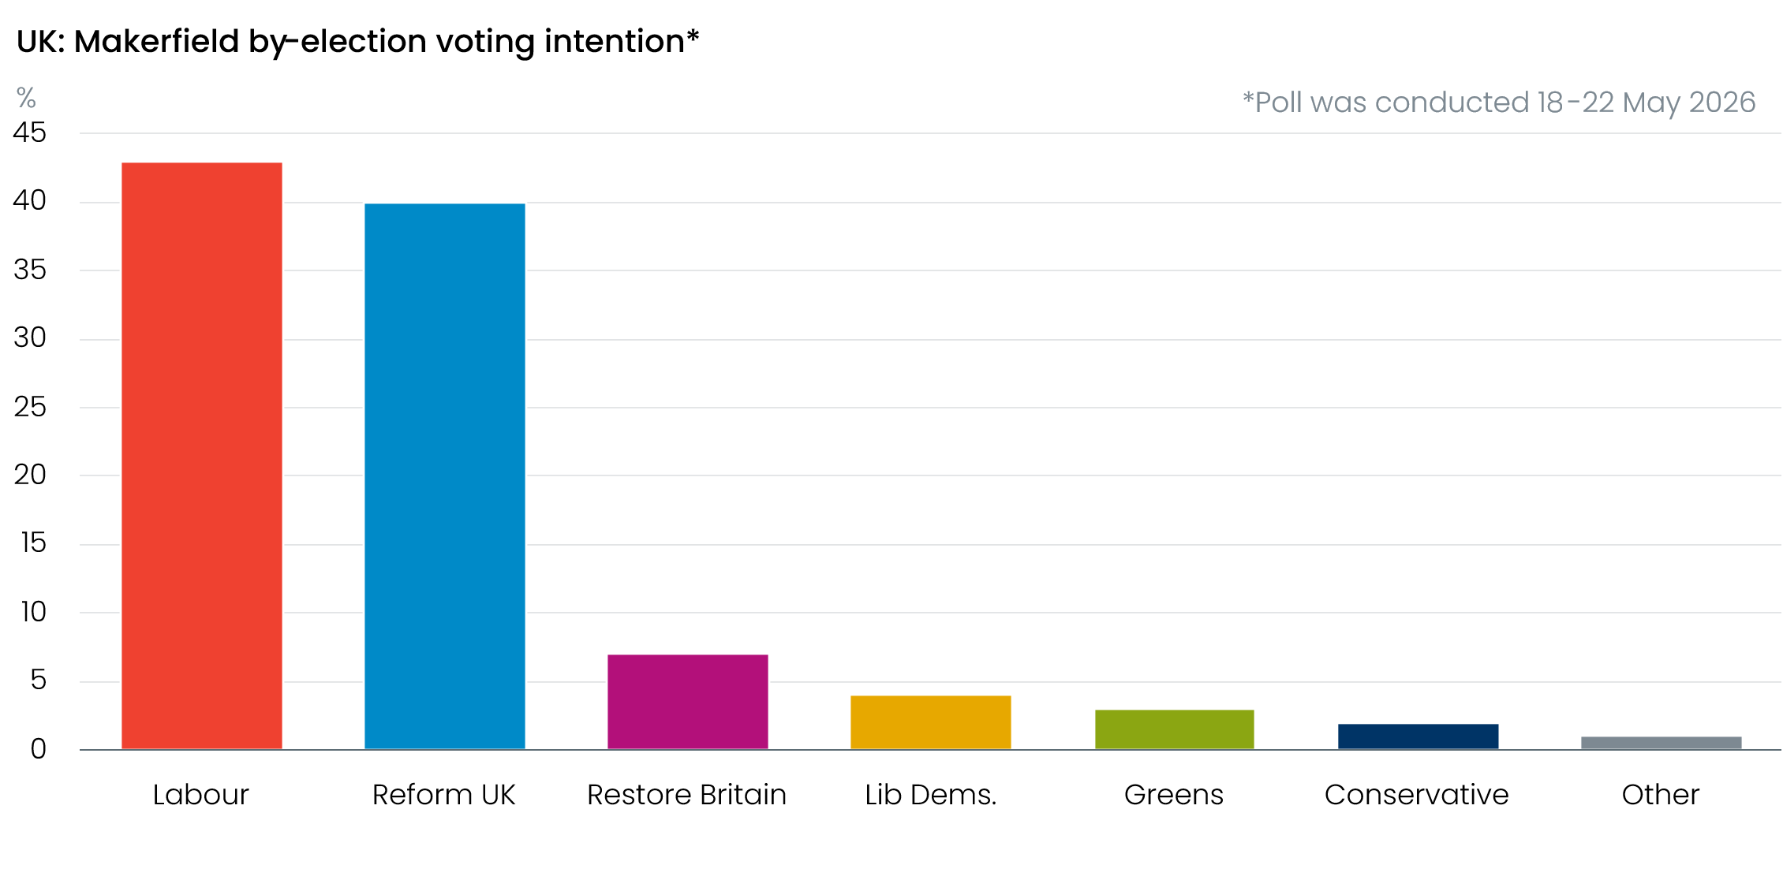
Sources: Survation
Amid the political uncertainty, the UK’s poor fiscal position means financial markets will be particularly sensitive to risks that the government could pursue a looser fiscal stance. As we’ve previously noted, all of the potential candidates to lead the Labour Party would likely propose a change in economic policy priorities, with most appearing to favour approaches that are likely to require more borrowing. Moreover, if Starmer successfully fights on as Prime Minister, we wouldn’t rule out the possibility of some near-term fiscal loosening materialising to boost his popularity and to cushion some of the blow to households from higher energy prices.
The implications of such a backdrop are that although we think market expectations for Bank Rate will gradually fall back further, rising term premia means we expect longer-dated gilt yields to remain elevated for the remainder of this year.

The week ahead
Next week should prove a little busier, with a few economic releases to look forward to. The Bank of England’s Money & Credit data for April is likely to garner some headlines. Mortgage approvals tend to follow movements in quoted mortgage rates with a short lag, so we think there’s a good chance that March’s 40bps-50bps jump in mortgage rates weighed heavily on mortgage activity in April. Therefore, we’ve pencilled in a drop in mortgage approvals to 61,500, from 63,531 in March. We also forecast net secured lending to come in at £4.5bn in April, down from £6.2bn a month earlier.
The week will also see the release of May’s S&P Global surveys. The flash survey reported a sharp pullback in private sector activity. This deterioration was concentrated in the services sector, with survey respondents linking the weaker reading to delayed investment and consumer spending decisions in response to uncertainty generated by the ongoing conflict in the Middle East. We expect next week’s final survey to reiterate this story and show a slightly less downbeat picture in the construction PMI, after a very large fall in April.
Table 1: Week ahead calendar
Date | Events | Period | Measure | Unit | Previous | Forecast
Jun 1 | S&P Global manufacturing | May | PMI | % bal | 53.7 | 53.7
Jun 2 | Mortgage approvals | Apr | Level | 000s | 63.5 | 61.5
Jun 2 | Mortgage lending | Apr | Net lending | £bn | 6.2 | 4.5
Jun 2 | Consumer credit | Apr | Net lending | £bn | 1.9 | 1.6
Jun 3 | S&P Global services | May | PMI | % bal | 47.9 | 47.9
Jun 3 | S&P Global composite | May | PMI | % bal | 48.5 | 48.5
Jun 4 | S&P Global construction | May | PMI | % bal | 39.7 | 43.2
Jun 5 | Halifax house prices | May | m/m | % | -0.1 | 0.1
Jun 5 | Halifax house prices | May | y/y | % | 0.4 | 1.0
Source: Oxford Economics

Key forecasts
Table 2: UK forecast overview
(ANNUAL PERCENTAGE CHANGES UNLESS SPECIFIED)
 | 2024 | 2025 | 2026 | 2027 | 2028 | 2029
GDP | 1.0 | 1.4 | 0.7 | 0.7 | 1.8 | 1.7
Private consumption | -0.1 | 0.8 | 0.6 | 0.4 | 1.5 | 1.8
Fixed investment | 1.7 | 4.3 | 0.3 | 1.5 | 2.5 | 2.1
Government consumption | 2.9 | 1.6 | 1.3 | 1.6 | 1.4 | 1.2
Consumer prices | 2.5 | 3.4 | 3.4 | 2.7 | 1.9 | 2.0
Unemployment rate (%) | 4.3 | 4.9 | 5.4 | 5.6 | 5.1 | 4.7
Current a/c balance (% of GDP) | -3.0 | -2.4 | -3.8 | -3.2 | -2.6 | -2.5
Government balance (% of GDP) | 5.2 | 5.0 | 4.0 | 3.8 | 3.0 | 2.6
Central bank policy rate (%, EOP) | 4.75 | 3.75 | 3.75 | 3.50 | 3.00 | 2.75
10yr govt. bond yield (%, EOP) | 4.57 | 4.47 | 5.13 | 4.57 | 3.87 | 3.55
Exchange rate (US$ per £, EOP) | 1.25 | 1.35 | 1.30 | 1.30 | 1.30 | 1.30
Exchange rate (euro per £, EOP) | 1.21 | 1.15 | 1.12 | 1.10 | 1.10 | 1.10
Source: Oxford Economics
Table 3: Quarterly forecasts for the UK
 | 2026 |  |  |  | 2027
 | Q1 | Q2 | Q3 | Q4 | Q1 | Q2 | Q3 | Q4
GDP (% year) | 1.1 | 0.9 | 0.6 | 0.4 | 0.2 | 0.5 | 1.0 | 1.3
CPI inflation (% year) | 3.1 | 3.0 | 3.6 | 3.9 | 3.7 | 3.0 | 2.3 | 1.9
Bank Rate (%, EOP) | 3.75 | 3.75 | 3.75 | 3.75 | 3.75 | 3.75 | 3.75 | 3.50
10yr gilt yield (%, EOP) | 4.88 | 5.10 | 5.14 | 5.13 | 5.09 | 4.96 | 4.78 | 4.57
US$ per £ (EOP) | 1.32 | 1.34 | 1.32 | 1.30 | 1.30 | 1.30 | 1.30 | 1.30
Euro per £ (EOP) | 1.14 | 1.16 | 1.14 | 1.12 | 1.11 | 1.10 | 1.10 | 1.10
Source: Oxford Economics

Latest Country Economic Forecast:
May 21, 2026

Recent publications

Data Insights
Public finances softer than expected
Weaker retail sales in April supports the case for Q2 slowdown
May’s flash PMIs signal a pullback in private sector activity
Inflation softened temporarily in April
Jobs market continues to cool

Research Briefings
Are European countries with high AI use seeing higher productivity growth?
Weak real incomes set to subdue consumer spending
Why 5% 10-year gilt yields are here to stay
MPC maintains a watching brief, but chances of higher rates are rising
Residual seasonality issues continue to flatter activity growth in Q1

Contacts

Oxford Economics' UK team
- Andrew Goodwin – Chief UK Economist – agoodwin@oxfordeconomics.com
- Edward Allenby - Senior UK Economist - eallenby@oxfordeconomics.com

